Cornerstone Comeback Grant Program
  - Invest in Your Property. Invest in Your Business. Invest in Southfield.
The Southfield Downtown Development Authority (SDDA) is investing in the continued revitalization of Southfield's Historic Cornerstone District through the Cornerstone Comeback Grant Program. Designed to encourage reinvestment, reduce barriers to business growth, and strengthen commercial properties, the program provides financial assistance and technical guidance for projects that improve the district's appearance, activate vacant spaces, and support new business investment.

Program Overview
The Southfield Downtown Development Authority (SDDA) Cornerstone Comeback Grant Program is designed to support property owners and businesses working to improve, activate, and strengthen Southfield's Historic Cornerstone District.
The program currently includes three grant opportunities:
- Cornerstone Comeback Business Opening Grant
Provides guidance and financial assistance to businesses and property owners pursuing a Cornerstone Comeback Business Opening. The program helps applicants navigate the occupancy process, activate commercial spaces, support business expansion, and reduce barriers to investment within the Cornerstone District.
- Cornerstone Curb Appeal Facade Improvement Grant
Supports exterior building improvements that enhance curb appeal and improve the appearance of commercial properties.
- Mid-Century Modern Address Numeral Grant
Encourages consistent, architecturally compatible address numerals inspired by Mid-Century Modern design to improve visibility and reinforce the character of the district.
Together, these grants encourage investment, support business activity, improve the appearance of commercial properties, activate underutilized spaces, and contribute to a more attractive, connected, and investment-ready Cornerstone District.

General Program Information

Eligibility
Applicants must own or operate a business or commercial property within the eligible area identified for each grant program. Tenants may apply with written authorization from the property owner when required.

Application Review
Applications will be reviewed by SDDA staff and/or a Grant Review Committee. The SDDA may request additional information, documentation, site visits, or presentations as part of the review process.

Funding Availability
Grant funding is limited and subject to available program funds. Submission of an application does not guarantee funding approval.

Project Timeline
The Cornerstone Comeback Grant Program closes annually on June 30.
Applicants whose project completion date extends beyond June 30 should provide a written explanation with their application. Reasonable project timelines will be considered during the application review process.
Applicants experiencing unexpected delays after approval should notify the SDDA and provide an updated project timeline.

Reimbursement Process
Cornerstone Comeback Grants are reimbursement-based. Approved applicants must complete the project and submit all required documentation before reimbursement will be issued.
- Required documentation may include:
- Paid invoices and receipts
- Before and after photographs
- Proof of payment
- Completed reimbursement forms
- Required permits, inspections, or approvals

City Review and Approvals
Some projects funded through the Cornerstone Comeback Grant Program may require permits, approvals, reviews, or inspections from the City of Southfield before work may begin.

Applicants are responsible for obtaining all permits, approvals, and inspections required for their project. Depending on the scope of work, review may be required by the:

Building Department

Planning Department

Engineering Department

Fire Department

Other City departments or agencies, as applicable

Approval of a grant application by the Southfield Downtown Development Authority (SDDA) does not waive, replace, or constitute approval of any permits, plans, inspections, reviews, or development activities required by the City of Southfield.

Applicants are encouraged to contact the appropriate City departments early in the planning process to determine applicable requirements and avoid project delays.

Project Documentation and Promotion

By accepting grant funding, applicants agree to provide photographs and project information requested by the SDDA. The SDDA may use project descriptions, photographs, and before-and-after images to promote the Cornerstone Comeback Grant Program and highlight investment within the Cornerstone District.

Questions

For questions regarding eligibility, project requirements, or the application process, please contact the Southfield Downtown Development Authority.

Cornerstone Comeback Business Opening Grant

Eligible Area
This grant is available to eligible properties and businesses located within the Southfield Downtown Development Authority (SDDA) Cornerstone District.

Purpose

The Cornerstone Comeback Business Opening Grant is intended to encourage business occupancy, activate commercial spaces, and reduce barriers to investment within the Cornerstone District.

In addition to providing reimbursement for eligible City of Southfield fees and related repairs or improvements, the program connects applicants with guidance and support from SDDA Grant Committee members who can help navigate the Certificate of Occupancy process and identify resources that may assist with project completion.

Eligible Applicants
Eligible applicants include:
- Existing businesses operating within the district
- Businesses currently operating without a Certificate of Occupancy
- New businesses locating within the district
- Existing businesses expanding within the district
- Property owners preparing commercial space for occupancy

Eligible Uses
Grant funds may be used to reimburse permit costs, inspections, and repairs required for issuance of the Certificate of Occupancy by the City of Southfield.
Examples may include:
- Building permit fees
- Plan review fees
- Inspection fees
- Repairs or improvements required by the City of Southfield as part of the Certificate of Occupancy process
The SDDA reserves the right to determine final reimbursements.

Ineligible Uses
The following expenses are not eligible:
- Utility connection fees
- Legal fees
- Equipment purchases
- Furniture or fixtures

Occupancy Process Assistance
Obtaining a Certificate of Occupancy may require permits, inspections, plan reviews, and approvals from multiple City departments.
As part of this program, SDDA Grant Committee members are available to help applicants navigate the process, identify potential requirements, connect with appropriate City departments, and locate resources that may assist with project completion.
The Grant Committee does not replace City staff, nor can it approve permits, inspections, or Certificates of Occupancy. However, the committee may serve as a resource to help applicants better understand the process and move their projects forward.
Applicants are encouraged to contact the Grant Committee as early as possible in the planning process. Early conversations can help identify project requirements, available resources, potential challenges, and opportunities for assistance before significant expenses are incurred.
Additional information regarding the City of Southfield development and occupancy process is available in the City of Southfield Guide to Development

Maximum Grant Reimbursement: Up to $5,000

Reimbursement Requirements
Reimbursement may be requested after a Certificate of Occupancy has been issued for the subject property and business.
Applicants must submit documentation of eligible paid costs. Additional reimbursement requirements are outlined in the General Program Information section.

Cornerstone Curb Appeal Facade Improvement Grant

Eligible Area
To qualify, the property must have an address located within the Northland Park area, located between Rutland Street and Southfield Service Drive on the following streets:
- Eight Mile Road
- Northland Park

Purpose
This grant supports exterior building improvements that enhance curb appeal, improve the appearance of commercial properties, and encourage reinvestment within the Northland Park area.

Eligible Uses
Grant funds may be used for:
- Exterior painting
- Masonry cleaning or repair
- Window and door replacement or restoration
- Exterior lighting improvements
- Decorative architectural elements
- Landscaping improvements
- Exterior façade materials and finishes
- Awnings and canopies
- Permanent exterior improvements visible from the public right-of-way

Design Guidelines

Style
Improvements should complement the architecture of the building and contribute positively to the visual character of the district. Applicants are encouraged to utilize design elements that reinforce the area's Mid-Century Modern heritage when appropriate.

Appearance
Applicants are encouraged to incorporate durable, high-quality materials and architectural details that enhance the appearance of the property and contribute positively to the district.

Visibility Standards
Projects should:
- Be visible from the public right-of-way
- Improve the appearance of the building frontage
- Contribute to a cleaner and more attractive streetscape

Maximum Grant Reimbursement: up to $5,000

Reimbursement Requirements
Reimbursement may be requested after approved façade improvements have been completed.
Applicants must submit before and after photographs documenting completed improvements. Additional reimbursement requirements are outlined in the General Program Information section.

Mid-Century Modern Address Numerals Grant

Eligible Area
To qualify, the property must have an address located within the Northland Park area, located between Rutland and Southfield Service Drive on the following streets:
- Eight Mile Road
- Northland Park

Purpose
The purpose of this grant is to encourage visually cohesive and architecturally compatible commercial address signage that reflects the district’s Mid-Century Modern character while improving building identification, visibility, and overall district appearance.

Eligible Uses
Grant funds may be used for:
- Purchase of new commercial exterior address numerals
- Installation of permanent address numerals
- Exterior mounting hardware and installation materials
- Professionally fabricated dimensional lettering or numerals
- Exterior lighting specifically associated with address numerals
Temporary, paper, vinyl-only, or non-permanent address numbers are not eligible.

Design Guidelines

Style
Address numerals should reflect a Mid-Century Modern design aesthetic.
The following font styles are strongly encouraged:
- Futura
- Kabel
- Neutraface
- Avant Garde Gothic
Similar geometric or modernist sans-serif typefaces may also be considered.

Appearance
Applicants are encouraged to utilize durable materials, simple geometric forms, clean lines, and high-contrast designs that maximize visibility and complement the building architecture.
Preferred materials include:
- Brushed aluminum
- Stainless steel
- Matte black metal
- Acrylic dimensional lettering
- Other architecturally compatible materials

Visibility Standards
Address numerals should:
- Be permanently affixed to the building
- Be clearly visible from the public right-of-way
- Be placed near the primary public entrance
- Be appropriately scaled to the building frontage
- Maintain strong readability during daytime and evening hours

Maximum Grant Reimbursement: up to $500

Reimbursement Requirements
Reimbursement may be requested after approved address numerals have been installed.
Applicants must submit photographs documenting the completed installation. Additional reimbursement requirements are outlined in the General Program Information section.

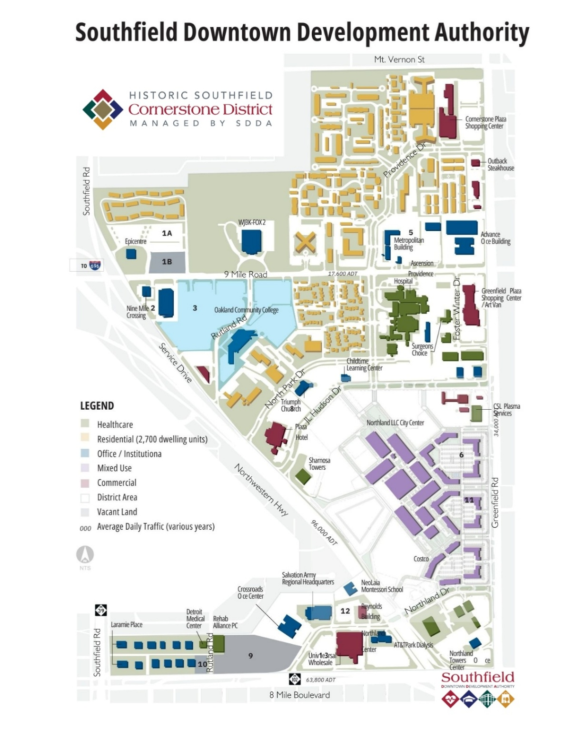
Map

Northland Park

Links

City of Southfield Guide to Development
Key Contacts, submittal information, and review process (link above)

Mid Century Modern Inspiration
DropCapStudios.com
AtomicAvocadoDesigns.com
GoHomeNumbers.com
ModMettle.com

Mid Century Modern Font Styles
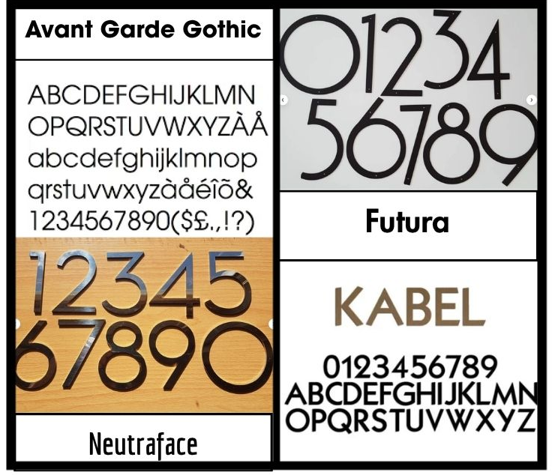

Before and After Commercial Façade Improvements
